

**Find A Doctor**

**Group Members:**

Deepika Subiri

Karma Dorji

Khushant Chetri

Tula Ram Galley

**Objective:**

The objective of this app is to consolidate all the laws (acts, rules and regulations, Supreme Court judgments, conventions) in a single container. This app will serve all the laws in the country and people need not have to visit different websites (since currently all the concerned agencies host their own laws) to find the laws of the country.

**Brief Description:**

When the app is first installed in the devices it will not contain the packages that contain the acts and laws. As the user start to use the app, the packages will be downloaded using internet connections. From next time, the users can view the content without any internet connection. User will be notified for updates when there is changes and update in the packages.

At the back-end, there will be a web application for administrator to update the contents.

1. **Splash Screen**

The splash screen will appear before the main screen loads.

1. **Home**

Home screen will appear after the splash screen which contents the basics functions of the app (acts, conventions, rules and regulations, publication, contact us and rate us).

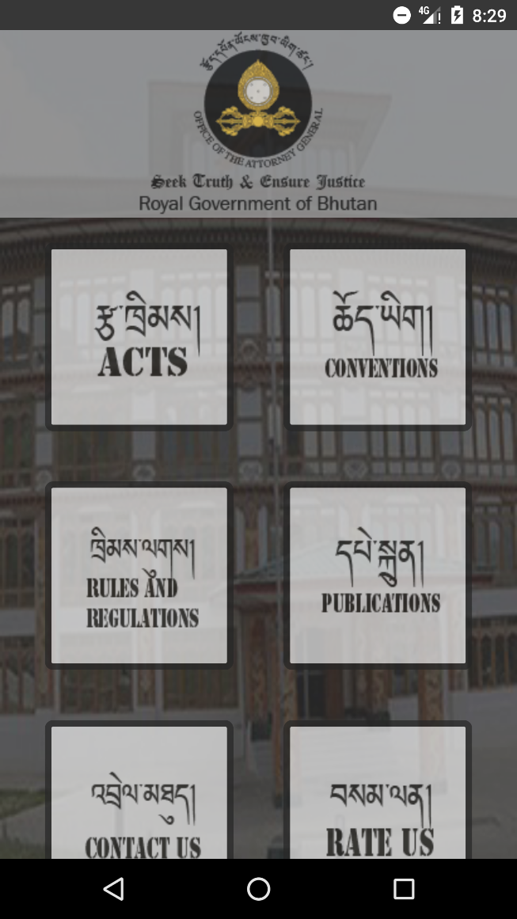

Fig 1.

1. **Acts**

***Acts*** is one of components that allows the users to view the acts of our country. Each acts will be listed in alphabetical order.

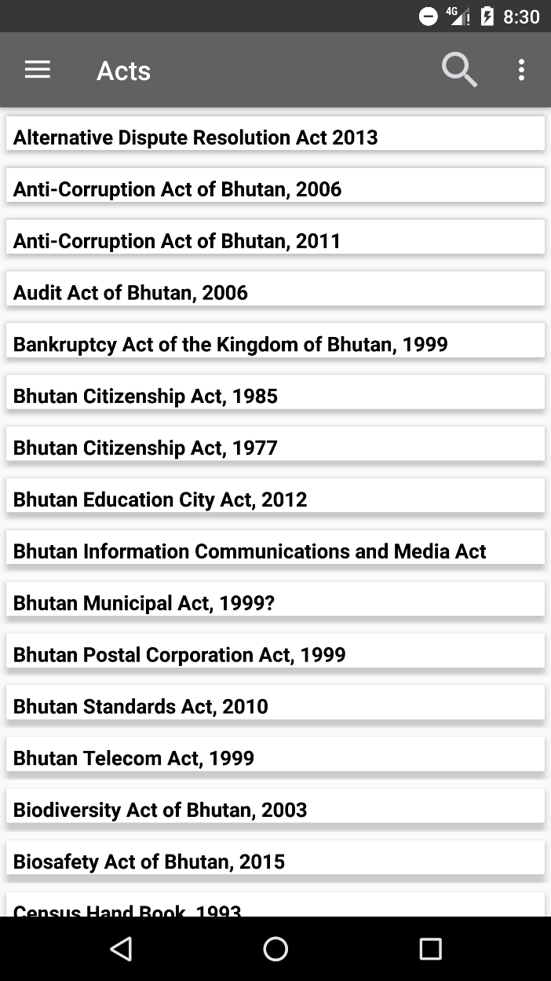

Fig 2.

* User can search for acts in search bar

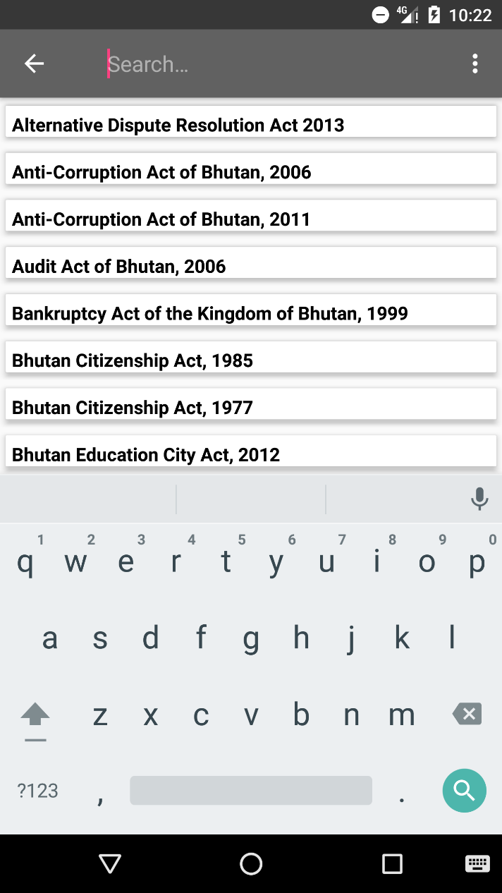

Fig 3.

* User can also view the contents that are available in Dzongkha by in Popup Menu

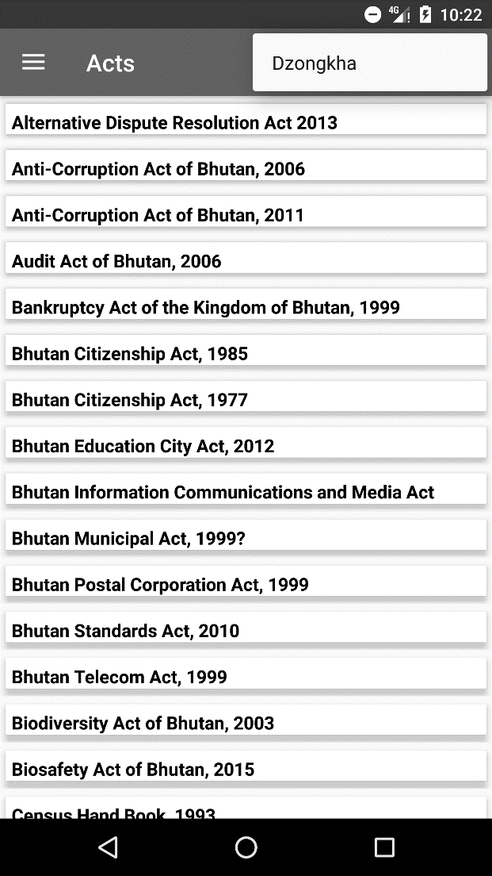

Fig 4.

* User can selects a specific navigation pane the menu bar is displayed at left corner of the screen and it allows easy accessible to all the menus in the same page without having to return to the home screen.

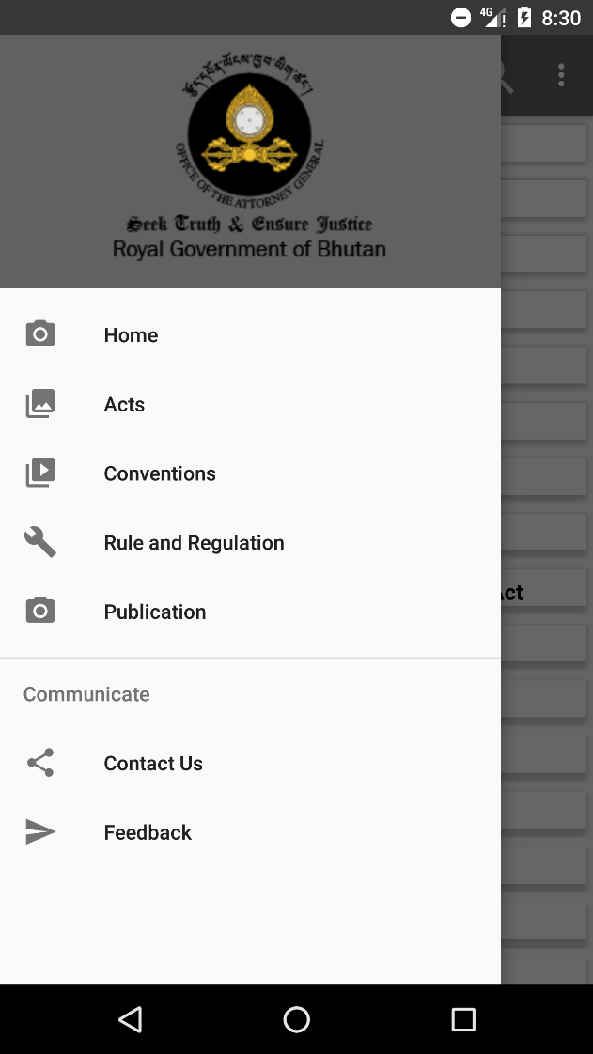

Fig 5.

* When user clicks on any of the acts listed, user will be directed to new page that contains contents of particular acts in a web view. Shown in Fig 6.

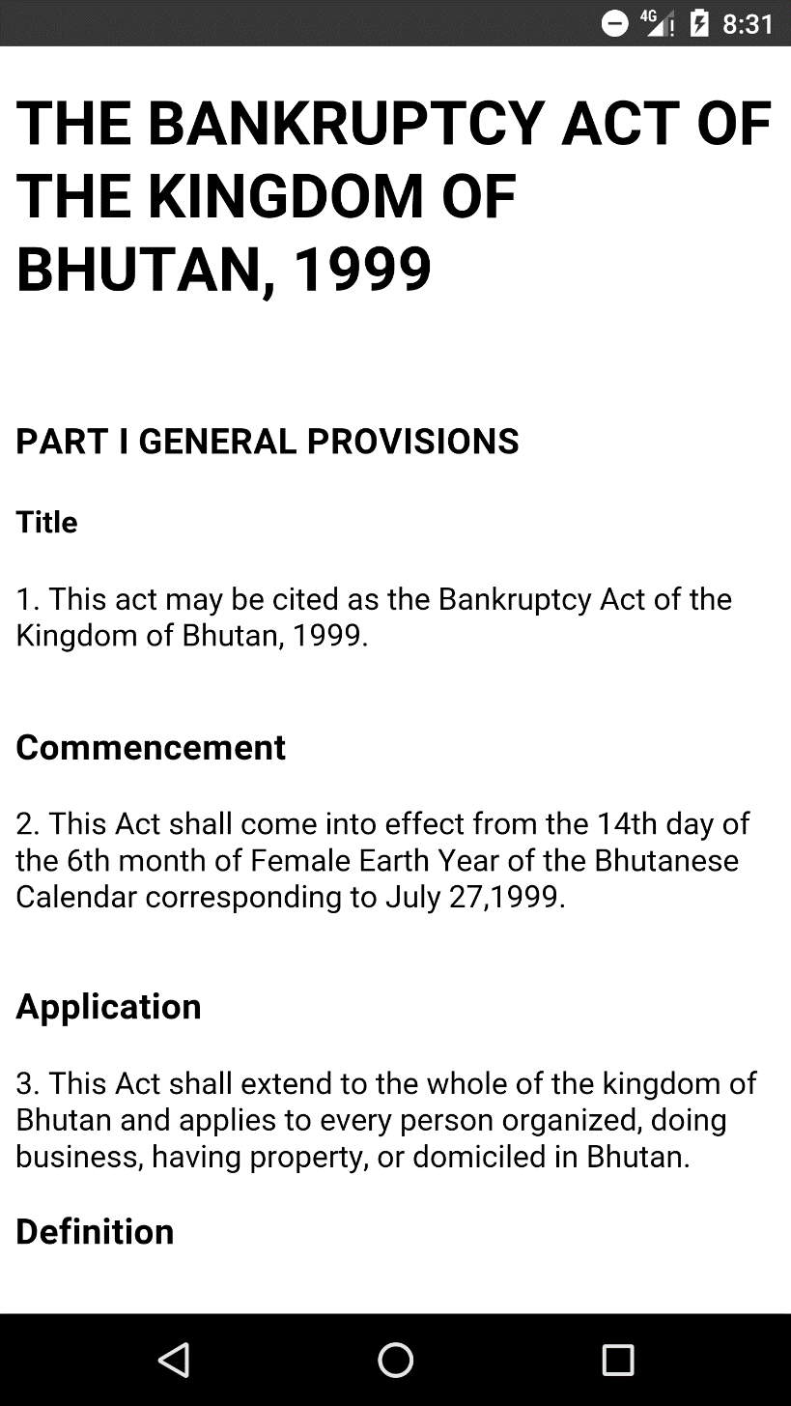

Fig 6.

1. **Conventions**

***Conventions*** is one of components that allows the users to view the conventions of our country. Each conventions will be listed in alphabetical order.

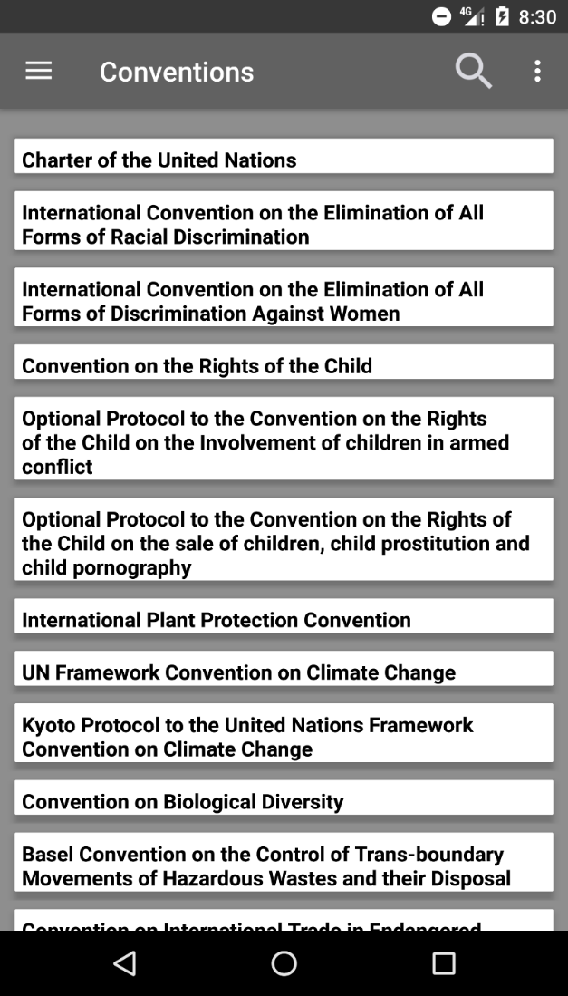

Fig 7

* User can search for conventions in search bar .

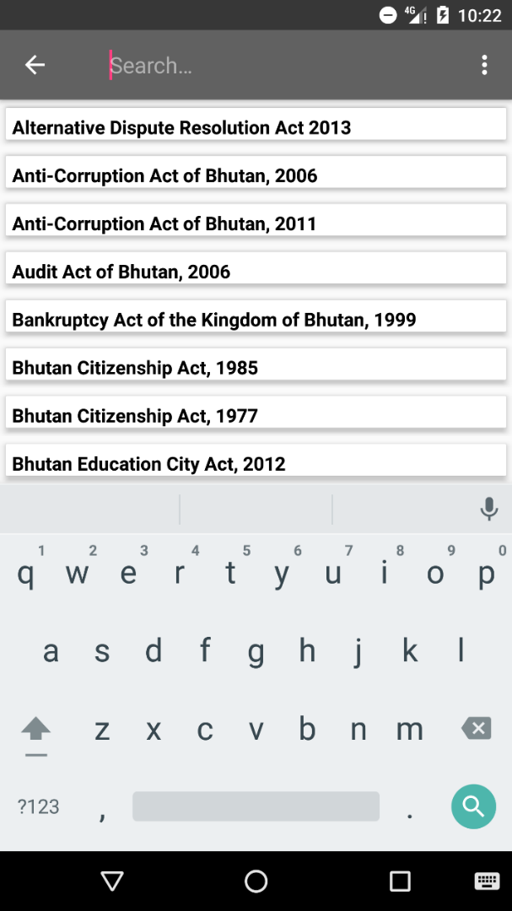

Fig 8.

* User can also view the contents that are available in Dzongkha by in Popup Menu



Fig 9.

* User can selects a specific navigation pane the menu bar is displayed at left corner of the screen and it allows easy accessible to all the menus in the same page without having to return to the home screen like in Fig 5.
* When user clicks on any of the conventions listed, user will be directed to new page that contains contents of particular acts in a web view which is similar to Fig 6.

1. **Rules and Regulation**

***Rules and regulations*** is one of components that allows the users to view the rules and regulations of our country. Each rules and regulations will be listed in alphabetical order.

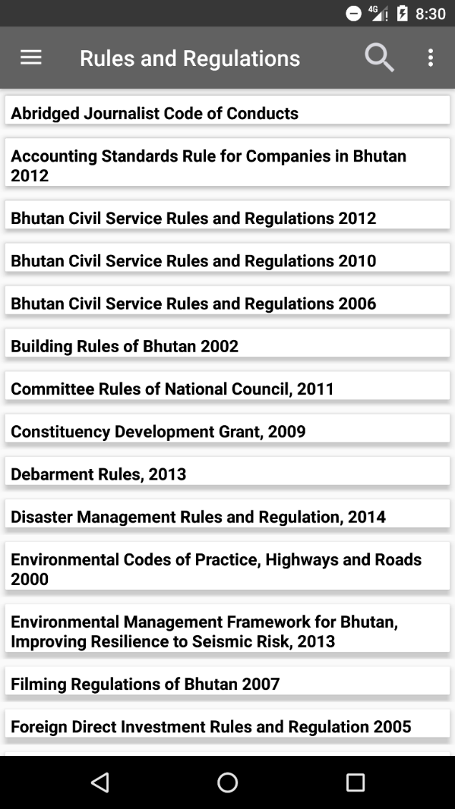

**Fig 10.**

* User can search for rules and regulations in search bar

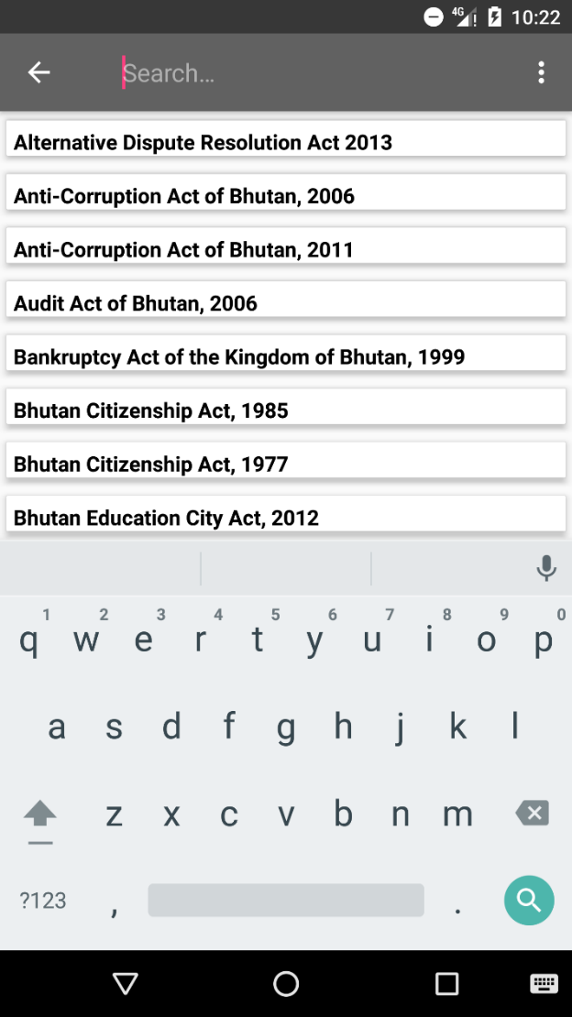

Fig 11.

* User can also view the contents that are available in Dzongkha by in Popup Menu



Fig 12.

* User can selects a specific navigation pane the menu bar is displayed at left corner of the screen and it allows easy accessible to all the menus in the same page without having to return to the home screen like in Fig 5.
* When user clicks on any of the rules and regulations listed, user will be directed to new page that contains contents of particular acts in a web view like in Fig6.

1. **Publication**

***Publications*** is one of components that allows the users to view the conventions of our country. Each conventions will be listed in alphabetical order.

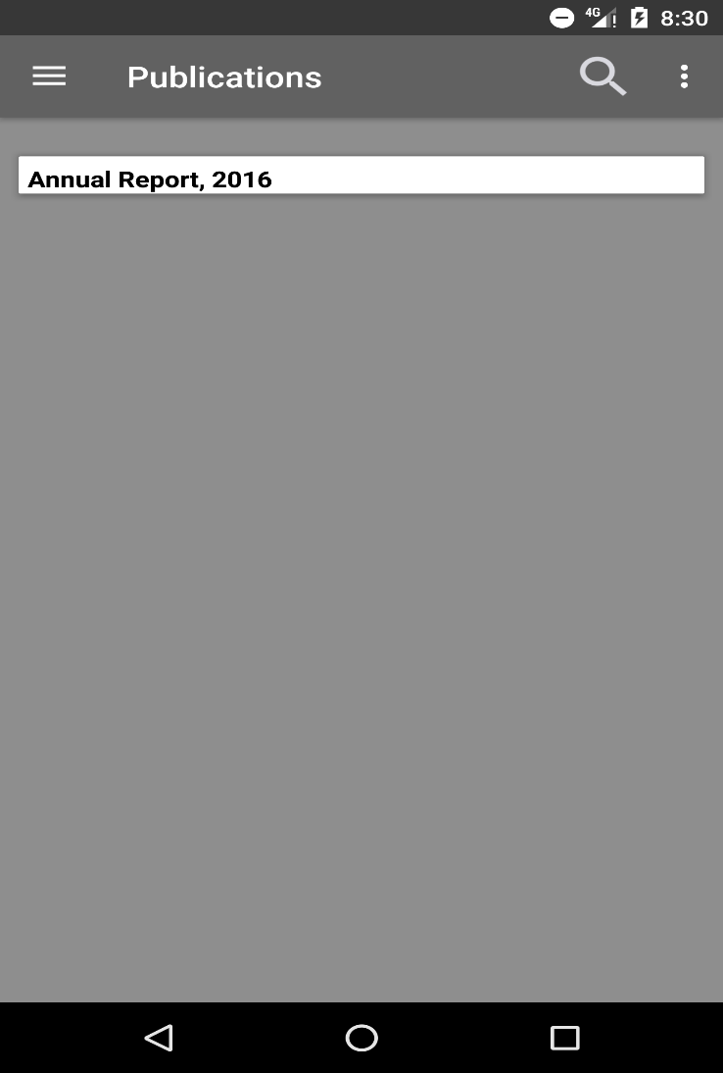

**Fig 13.**

* User can search for publications in search bar

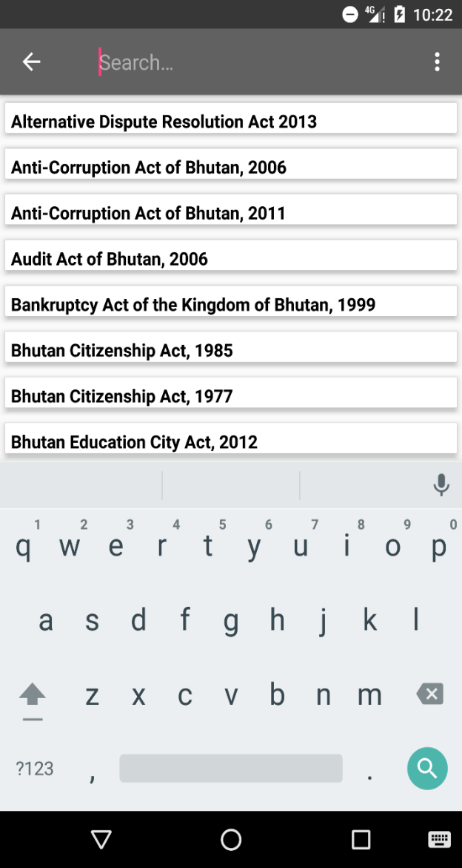

Fig 14.

* User can also view the contents that are available in Dzongkha by in Popup Menu



Fig 15.

* User can selects a specific navigation pane the menu bar is displayed at left corner of the screen and it allows easy accessible to all the menus in the same page without having to return to the home screen as shown in Fig5.
* When user clicks on any of the publications listed, user will be directed to new page that contains contents of particular acts in a web view as shown in Fig 6.

1. **Contact Us**

This section consists of OAG office Telephone number and fax number and other required addresses.

1. **Rate Us**

This enables users to rate the app where it will be linked to play store when user clicks the rate us navigation pane.